HOME SERVICE SYSTEM..

* **USE CASE DIAGRAM**

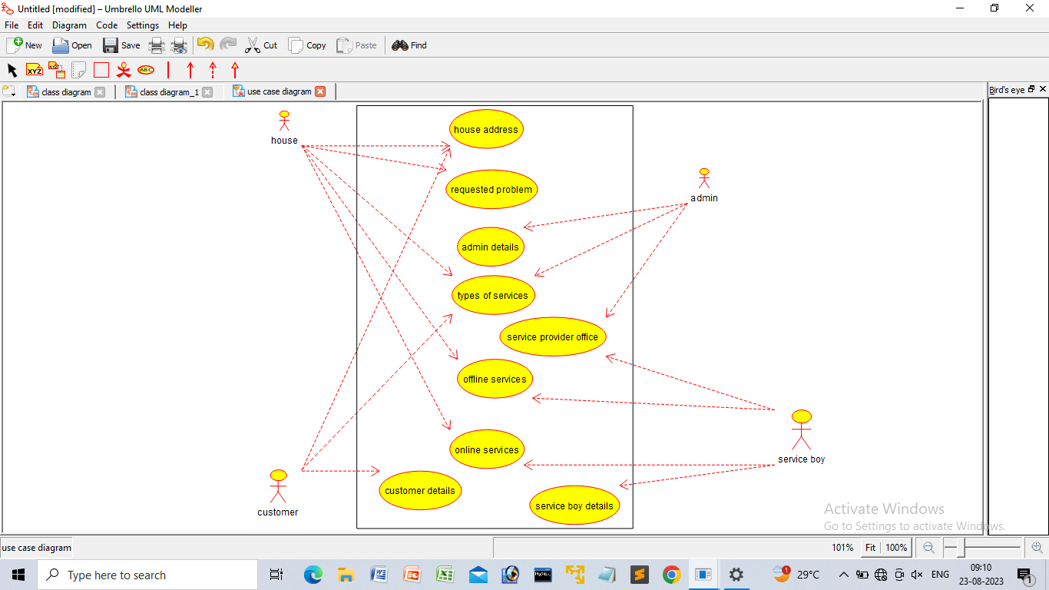

* **CLASS DIAGRAM**

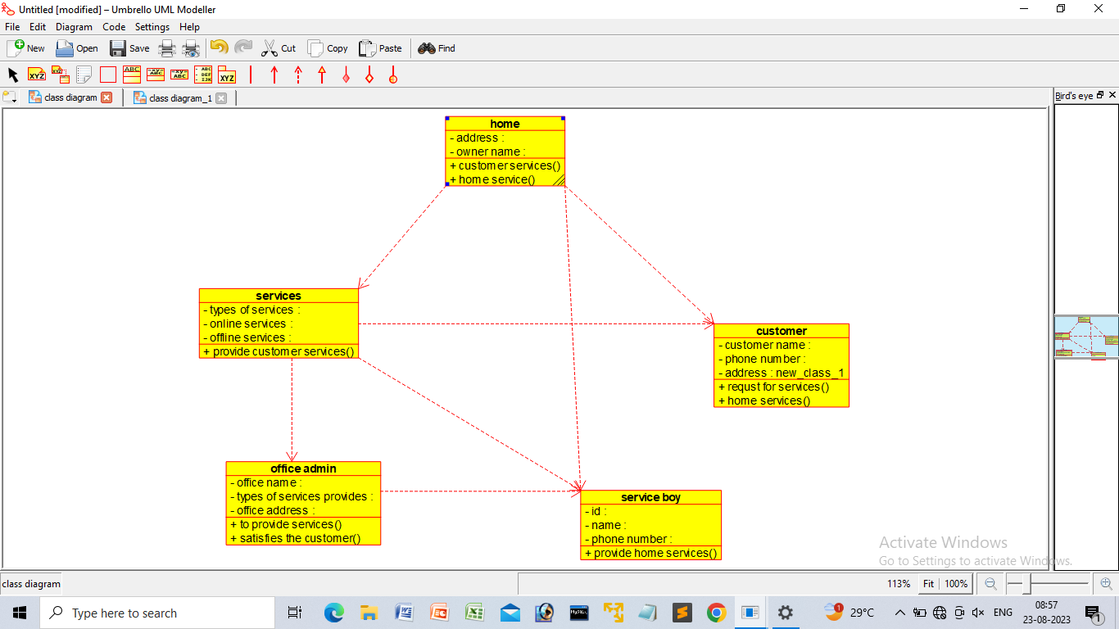

* **ACTIVITY DIAGRAM**

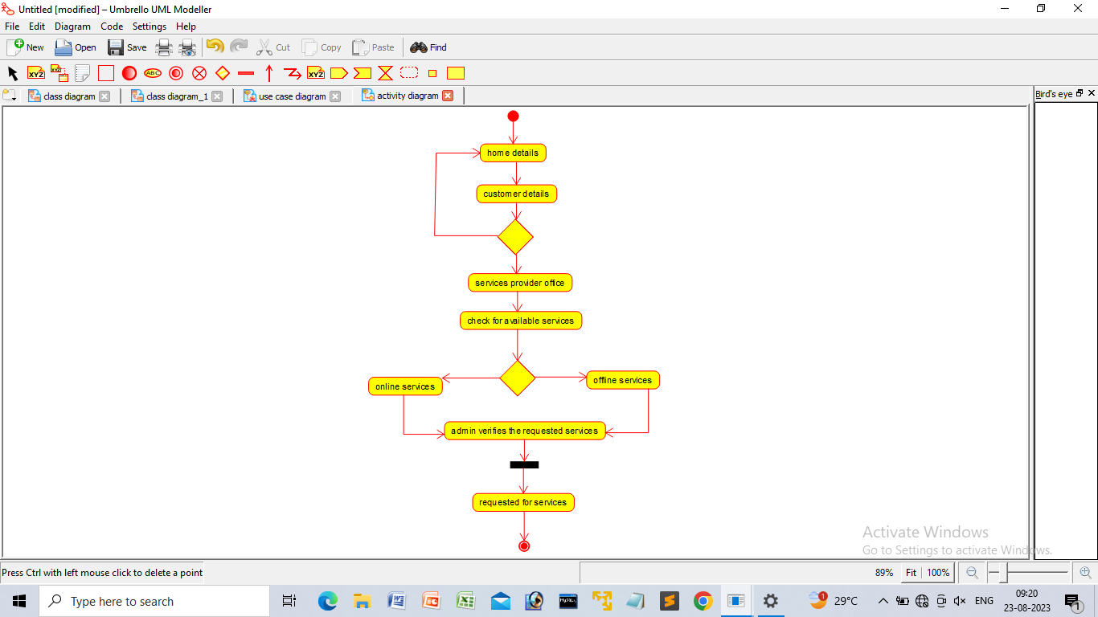

* **STATE CHART DIAGRAM**

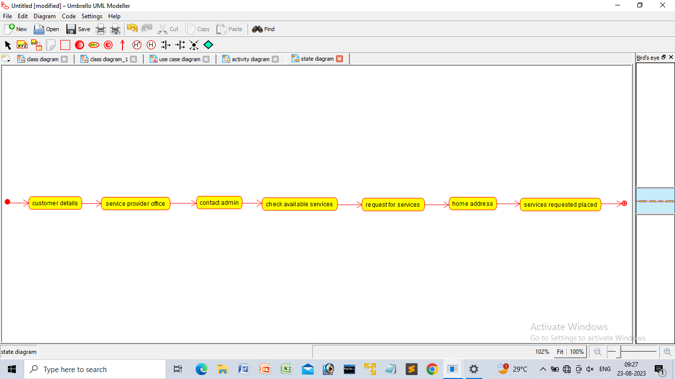

* **SEQUENCE DIAGRAM**

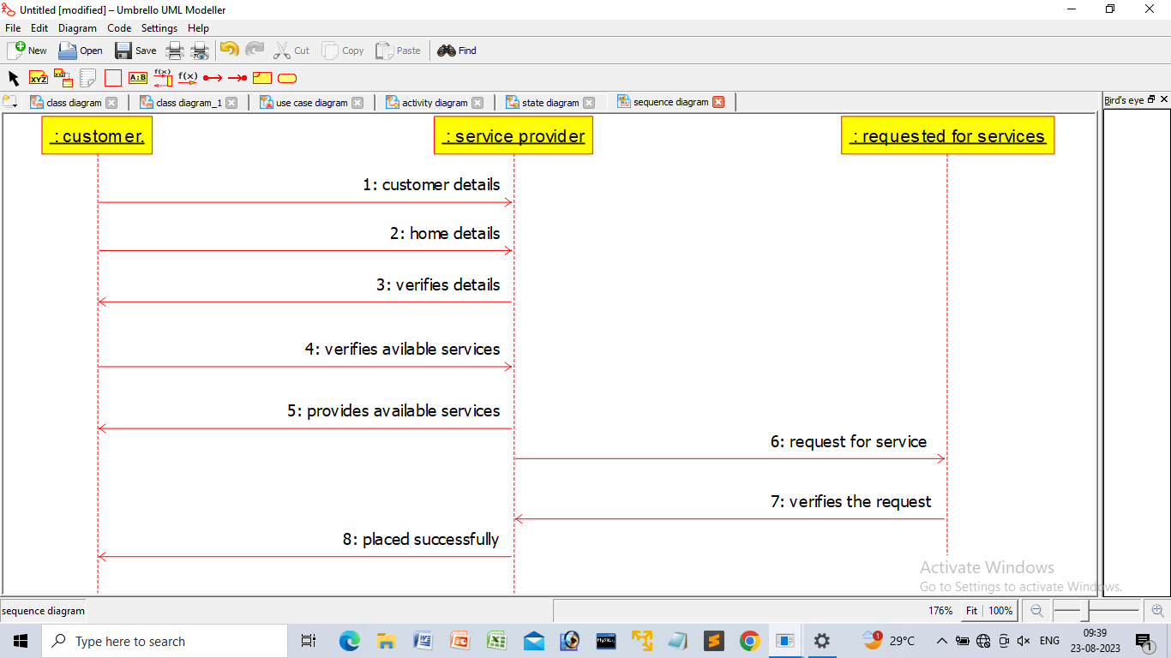

* **COLLABORATION DIAGRAM**

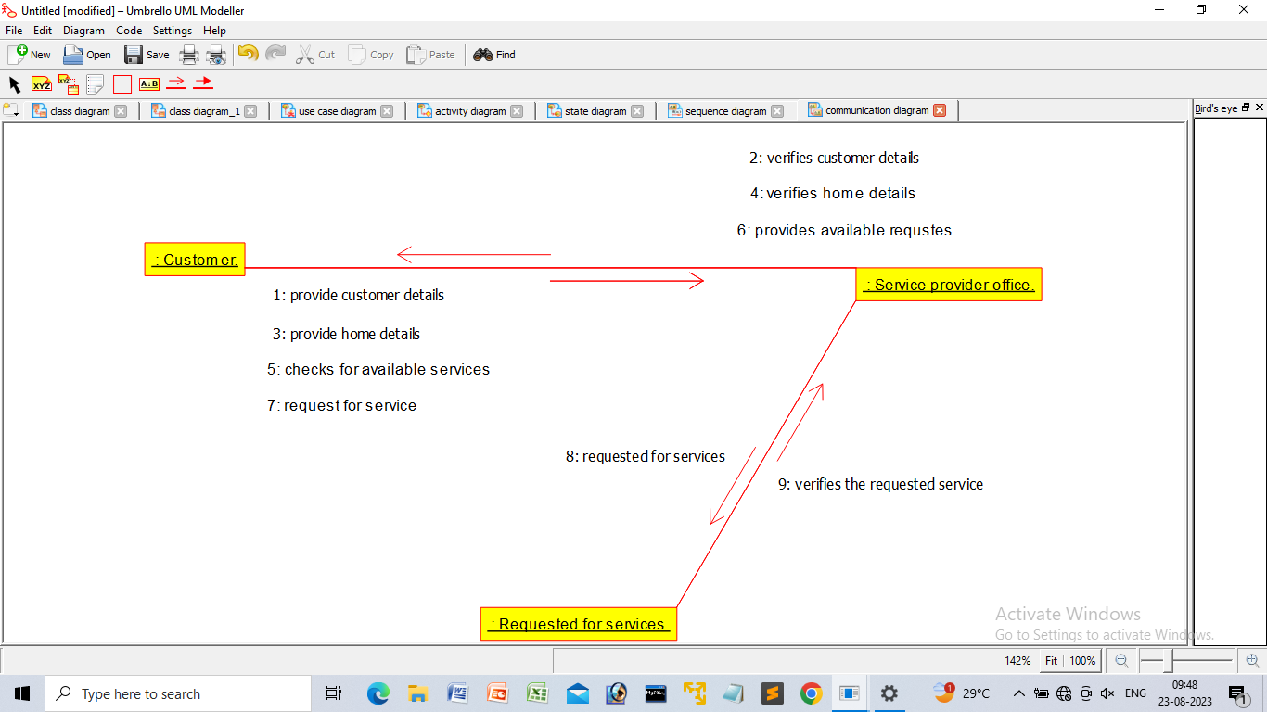

* **COMPONENT DIAGRAM**

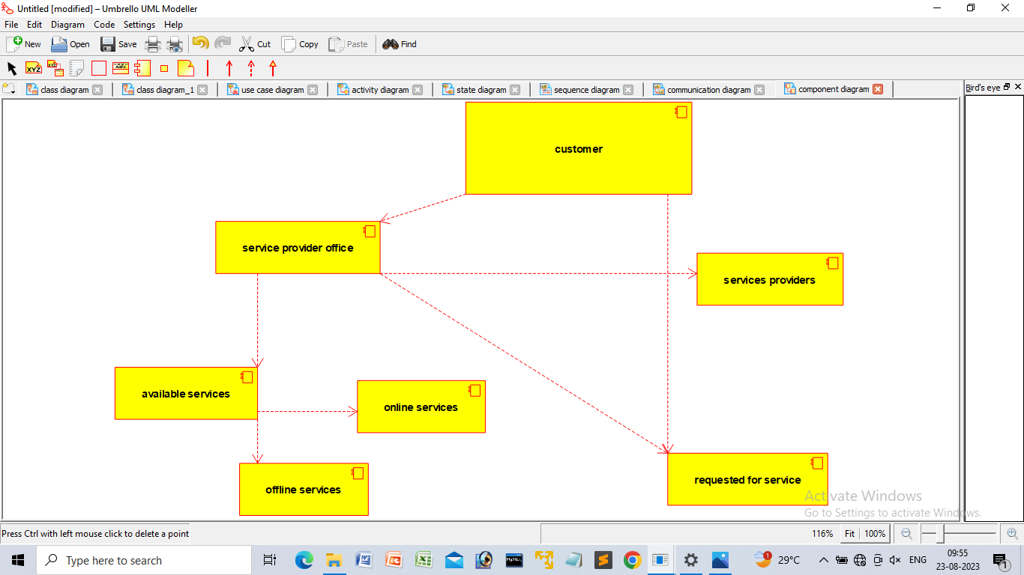

* **PACKAGE DIAGRAM**

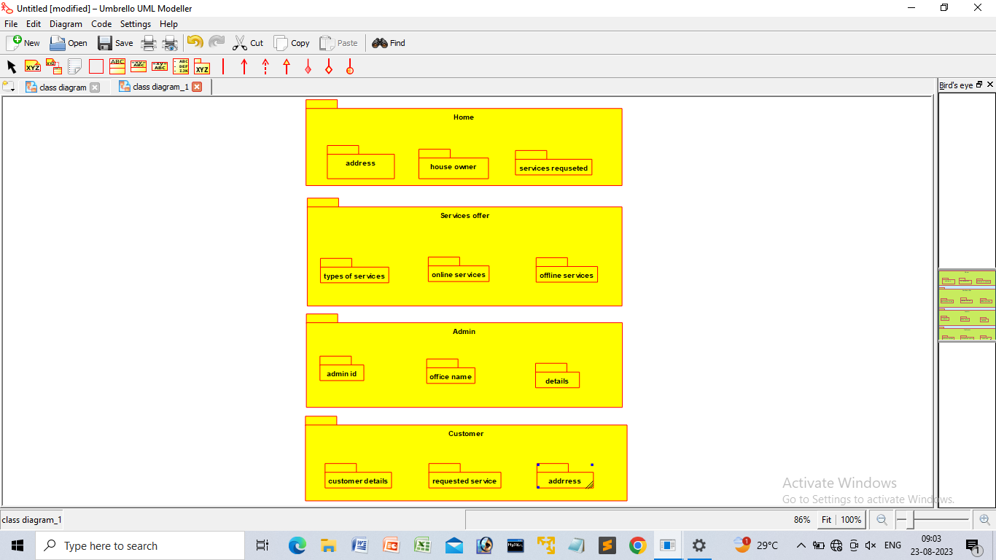

* **DEPLOYMENT DIAGRAM**

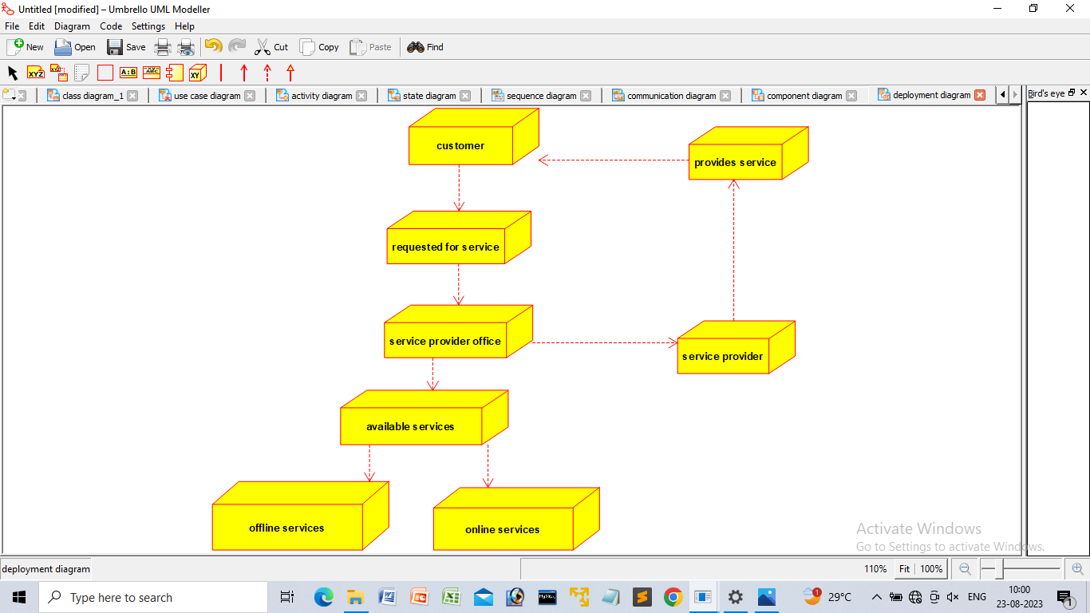

* **PROGRAM**

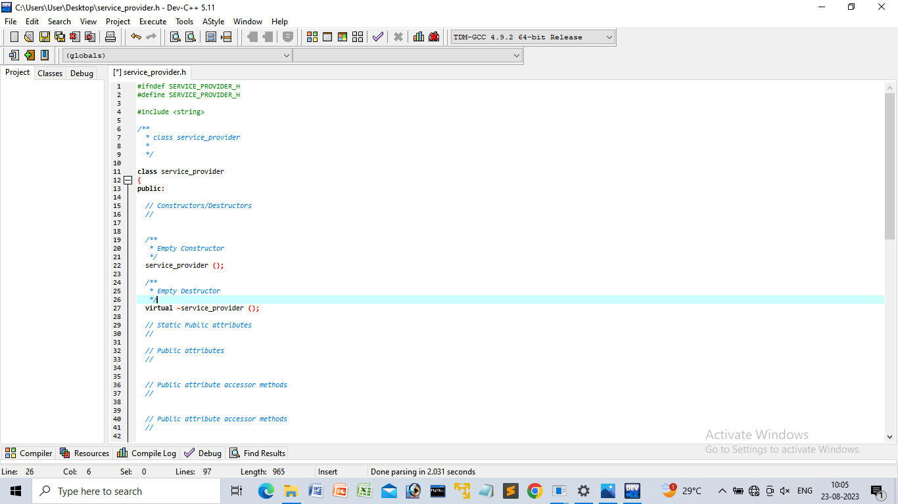

ONLINE INTERNSHIP REGISTRATION

* **USE CASE DIAGRAM**

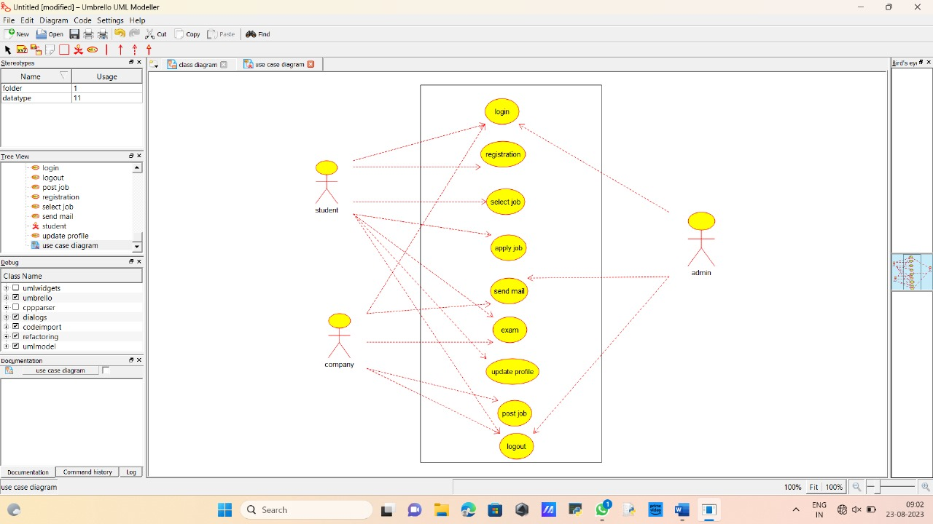

* **CLASS DIAGRAM**

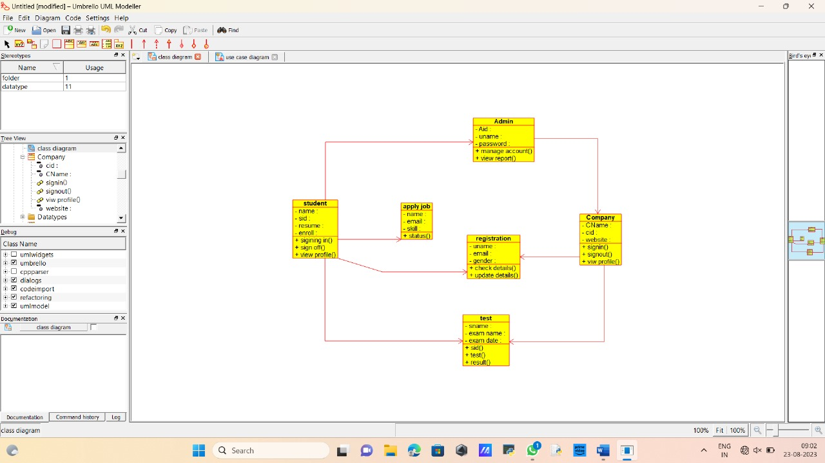

* **ACTIVITY DIAGRAM**

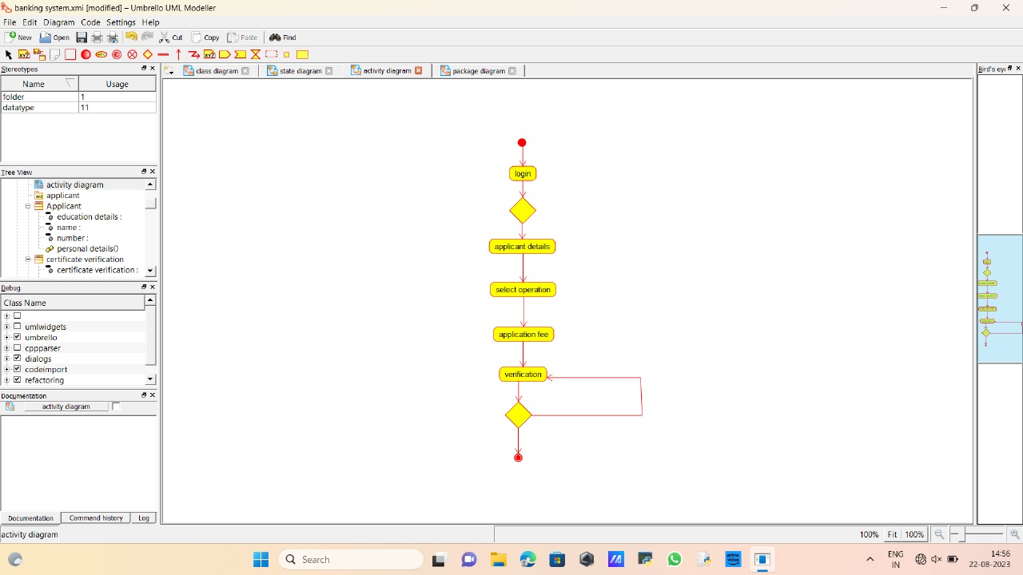

* **STATE CHART DIAGRAM**

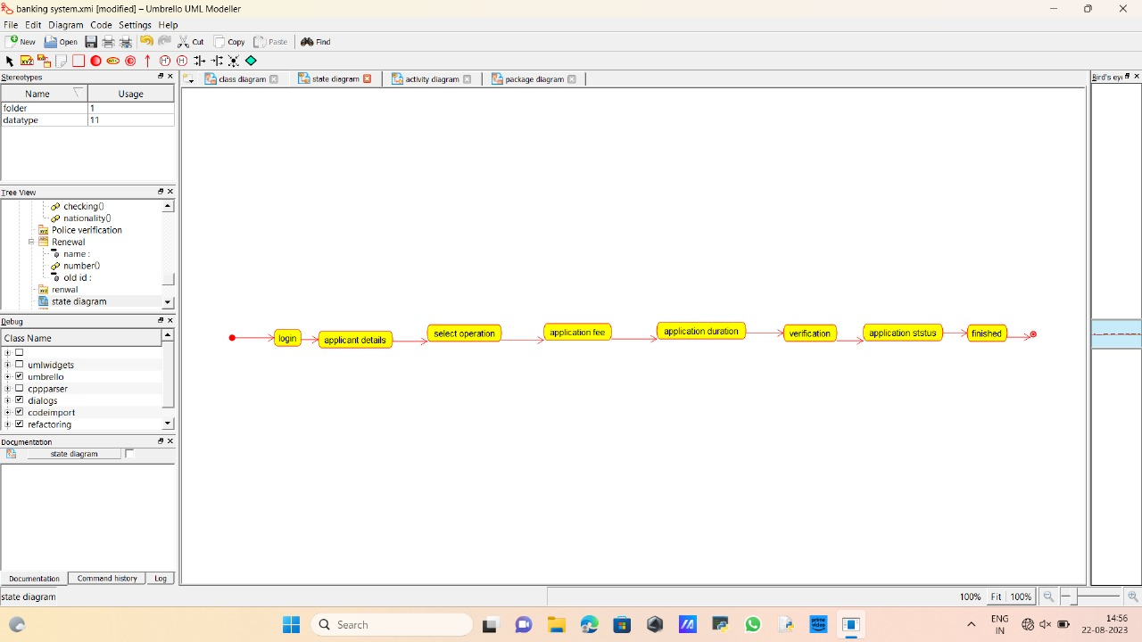

* **SEQUENCE DIAGRAM**

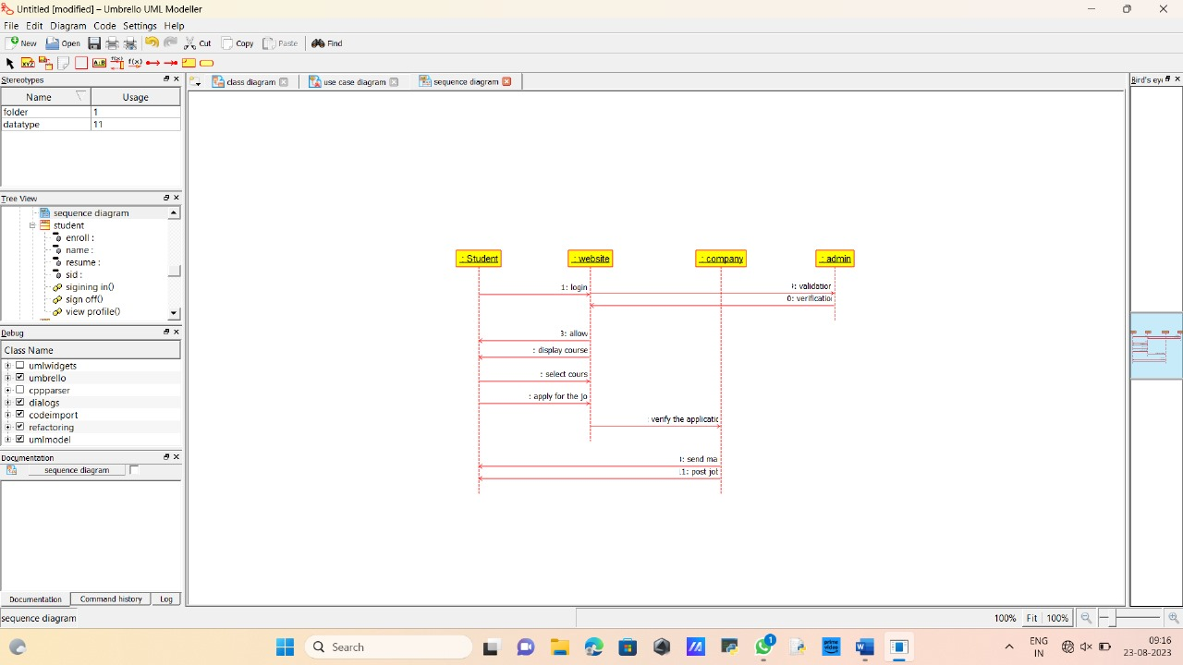

* **COMMUNICATION DIAGRAM**

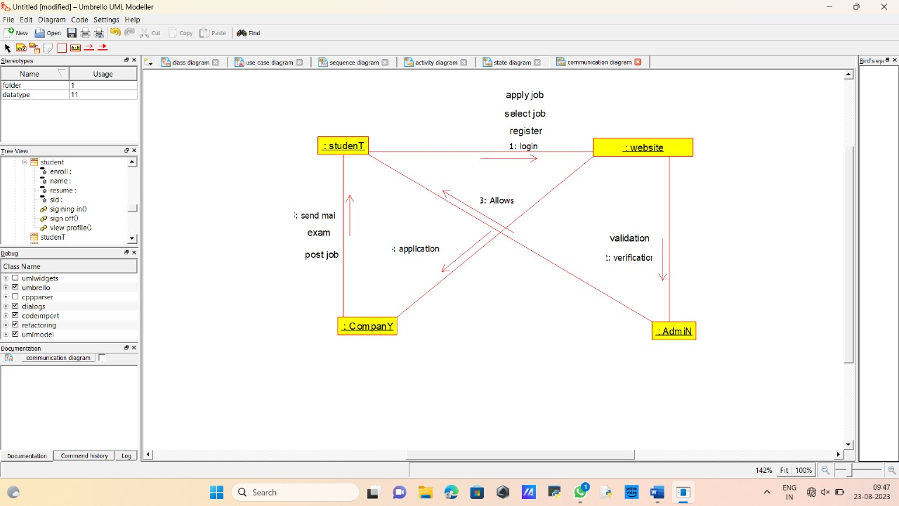

* **COMPONENT DIAGRAM**

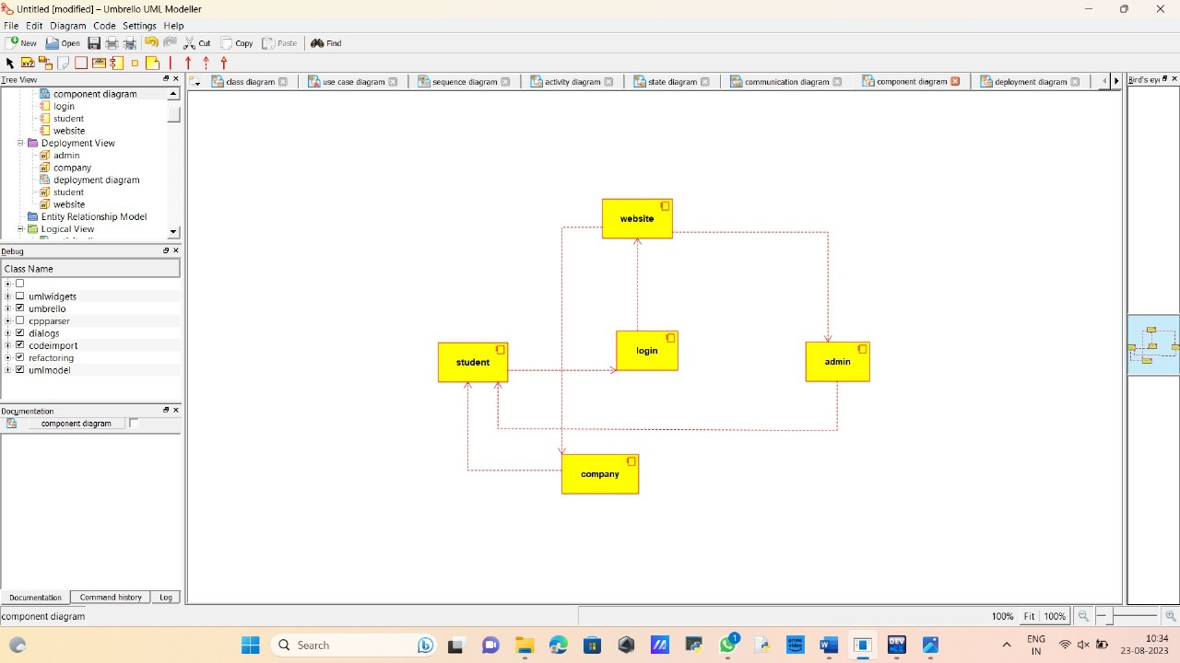

* **PACKAGE DIAGRAM**

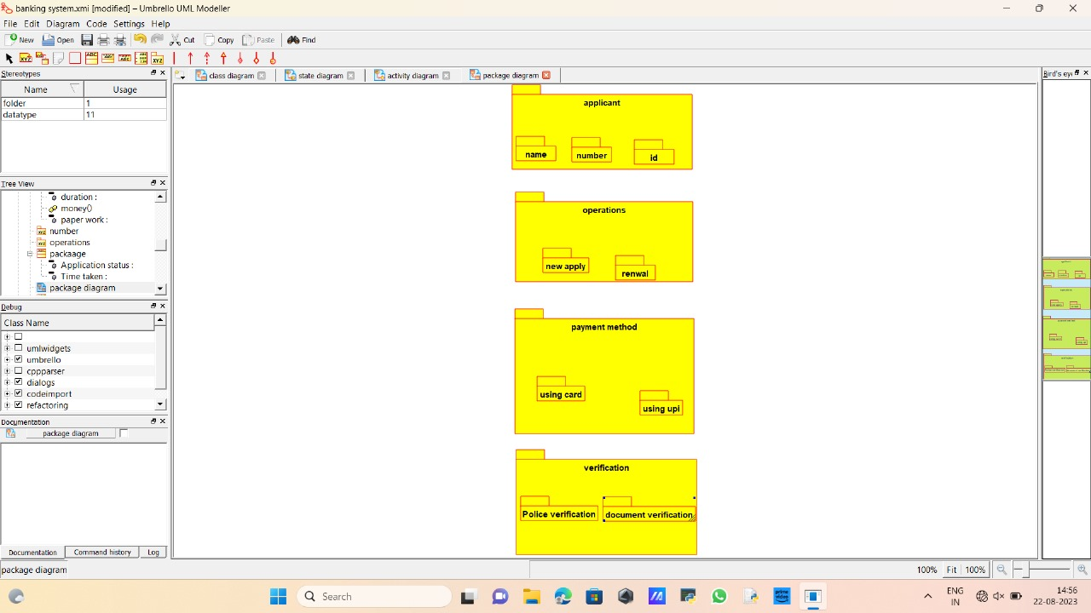

* **DEPLOYMENT DIAGRAM**

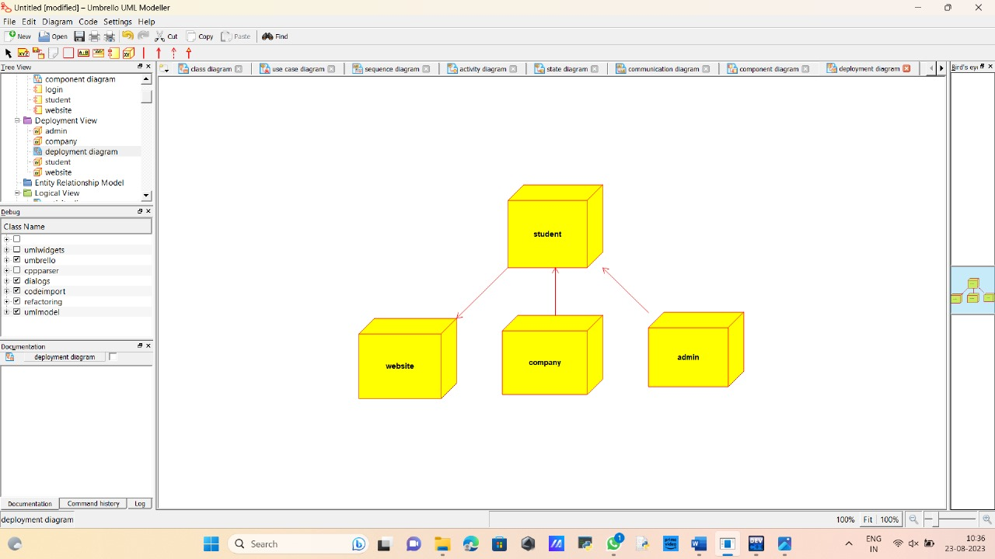

* **PROGRAM**

